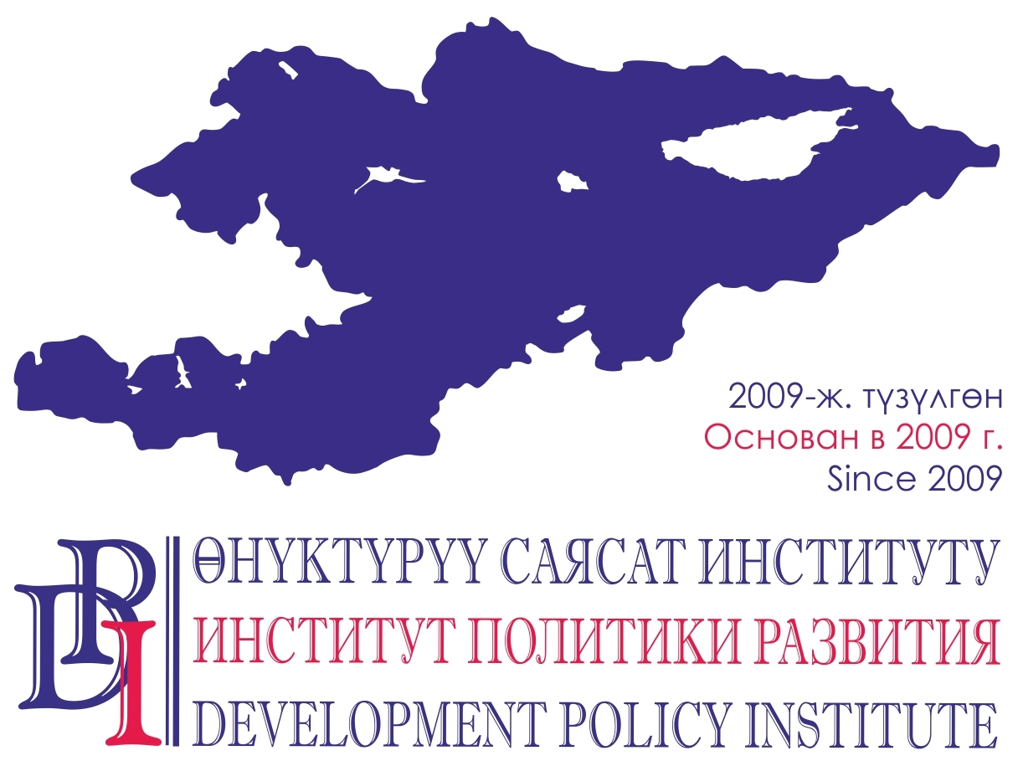
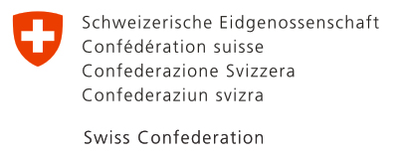

Voice of Citizens and Accountability of LSG: Budgetary Process
114, Shevchenko St., Bishkek, 720001. Tel. (0312) 97-65-30 (31, 32), Fax: 97-65-29, office@dpi.kg, www.vap.kg

February 28, 2022.
Osh-Bishkek, Kyrgyzstan PRESS RELEASE

LOCAL SELF-GOVERNMENT IN KYRGYZSTAN:
WILL ACCOUNTABILITY OF LOCAL SELF-GOVERNMENT BODIES
LEAD TO A BETTER LIFE FOR CITIZENS?

From February 28 to March 3, 2022 in Osh and Bishkek the local self-governments, representatives of local communities will study experience of the Kyrgyz Republic, Kazakhstan, Uzbekistan, Latvia, Switzerland, the Netherlands, the Russian Federation, Turkey, Mongolia and other countries in local development. The conference on "Improved Livelihood through Joint Efforts of LSG and Citizens” will explore how citizens can participate in the budget process, plan the development of economy, space and society, monitor services.
Goal of the international conference is to demonstrate practical examples of citizen participation that makes a valuable contribution to the development of cities and villages and is a prerequisite for a state governed by the rule of law. The conference program includes presentations by state and LSG bodies of the Kyrgyz Republic, the Congress of Local and Regional Authorities of the Council of Europe and representatives of the above countries.
The conference participants will learn, for example, what opportunities the Online Civic Budget provides during the pandemic in Kyrgyzstan, how local participation budgets are structured in Russia and Mongolia, what opportunities citizens of Switzerland have to influence the development, how local social services are organized with the NGOs’ help in Kazakhstan and Kyrgyzstan.
“In today's world, success of a territory is determined not so much by available resources as by the ability and skills to implement new management technologies and harness creative power of the population. An important factor in the success of local self-government is qualitative and conscientious interaction with citizens, providing them with effective opportunities to realize their ideas for organizing life on the territory and making their contribution to the local development. Given the rapidly growing volume of practices and knowledge on this issue, there is an obvious need for their dissemination”, - says Bekbolot Bekiev, the project manager.
The conference is organized by: the State Agency on Civil Service and Local Self-Government under the Cabinet of Ministers of the Kyrgyz Republic, Union of Local Self-Governments of the Kyrgyz Republic, PA “Development Policy Institute” and the Academy of Local Government of Central Asia.
All conference materials and best practice examples will be posted on the LSG Best Practices Portal of the Kyrgyz Republic: www.myktyaimak.gov.kg
The event is dedicated to the completion of the “Voice of Citizens and Accountability of LSG: Budgetary Process” Project financed by the Government of Switzerland and implemented by the Development Policy Institute in the Kyrgyz Republic from 2011 to 2022. Read more about the project results here: www.dpi.kg
For more details for the media: Nurgul Djamankulova, Project PR Specialist: 0555 / 0500 313-385, 0770 771-711, njamankulova@dpi.kg

