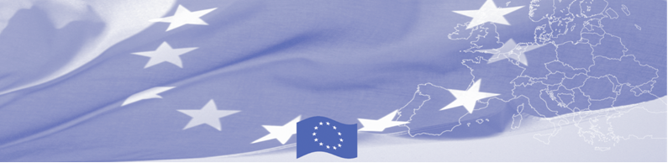

**PRESS-RELEASE**

**Project ‘Yntymaktuu Zhashoo (Living in Peace)’ is expected to be launched in Kyrgyzstan to promote peace initiatives and positive political culture**

**Bishkek, 20 of May 2021**

International Alert, in collaboration with the National Mediation Center (NCM) and Development Policy Institute (DPI), launches the European Union-funded ‘’Yntymaktuu Zhashoo’’ project. The goal is to support active youth, civil society and local self-government bodies in conflict prevention, support of rule of law, effective governance, and mediation in 25 districts of Kyrgyzstan.

In the framework of the project, it is planned to conduct localised research which will serve as a basis for training methodology on conflict sensitivity, conflict prevention, and mediation for civil society members and local self-government bodies at the local level.

“We are glad to support local initiatives for prevention of potential conflicts in local communities. It is important for the EU to contribute to stability and unity of people through such dedicated projects. As part of the project, also small grants will be provided to local government bodies to support governance and rule of law at local level’’, - the Head of EU Delegation, Ambassador Eduard Auer said.

The project will also include higher level dialogue on necessary measures to support governance, rule of law, public security, and capacity needs to prevent potential conflicts leading to inter-regional (inter-ethnic) or any other type of violence.

"Our goal is to create a resilient civil society, with strong peace-oriented youth movements, and a more effective implementation of local government mandates in conflict prevention. We want to engage active young people into dialogue to promote a peaceful rhetoric and positive political culture with conflict prevention mechanisms’’ according to Shakirat Toktosunova, International Alert Representative in the Kyrgyz Republic, Gulsina Kojoyarova, NCM representative and Nadezhda Dobretsova, IPR Board Chair.

**For reference:**

International Alert, with local organisations the National Centre for Mediation (NCM) and Development Policy Institute (DPI), will support youth volunteer groups, civil society, and local self-government bodies to improve conflictanalysis, conflict-prevention, and mediation skills in 25 districts.

**About International Alert:**

International Alert is an independent international peacebuilding and conflict prevention organization founded in 1986 to help people find peaceful solutions to conflicts.

In Kyrgyzstan, International Alert has been operating since 2010: www.international-alert.org. For additional information, please contact Iuliia Babiuk, Communications Consultant: +996 312 988811; +996 770 02 37 17

|  |  |  |
| --- | --- | --- |
|  |  |  |

|  |  |  |  |
| --- | --- | --- | --- |
| eu_logo |  |  |  |
| The program is funded by the European Union.  Boulevard Erkindik 21, Business Center “Orion”, 5th floor    Bishkek, 720040, Kyrgyz Republic  Phone: +996 312 26 10 00 Fax: +996 312 26 10 07  Email: [delegation-kyrgyzstan@eeas.europa.eu](mailto:delegation-kyrgyzstan@eeas.europa.eu%20)  Website:http://eeas.europa.eu/delegations/kyrgyzstan  Facebook:<http://www.facebook.com/eudelkg>  The European Union includes 27 member states that have united the advanced achievements, resources and destinies of their peoples. For 60 years together, they have managed to create a zone of stability, democracy and sustainable development, while preserving cultural diversity, personal freedoms and an atmosphere of tolerance. The European Union steadily strives to transmit and annex to its achievements and values countries and peoples that are beyond its borders. | The project implemented by the local office of International Alert in the Kyrgyz Republic | The organisation is a p rofessional association. It promotes mutual understanding in cross-cultural communication and has in-depth partnerships with the Supreme Court of the Kyrgyz Republic (KR). The center has active regional offices in all districts of Kyrgyzstan. | DPI’s expertise covers LSGs  (including Chapter VIII of the  Constitution of KR, regulations  on LSGs’ financial and economic  basis, decentralisation, regional  development, and public finances).  DPI is a prominent organisation  with intergovernmental working  groups related to LSGs and regional development. |