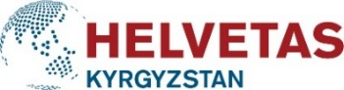
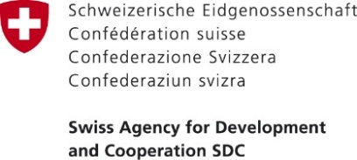
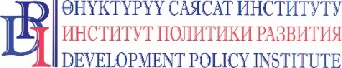

PRESS RELEASE

April 30, 2020
Bishkek, Kyrgyzstan

Swiss project supports municipalities of Issyk-Kul and Jalal-Abad regions to help vulnerable people
In view of the unprecedented situation due to the COVID-19 pandemic outbreak in the country, the Swiss Public Service Improvement (PSI) project allocated 750,000 soms to 15 project municipalities in Jalal-Abad and Issyk-Kul regions of Kyrgyzstan.
The allocated funds were used to provide basic food and hygiene products for the vulnerable groups of population in partner municipalities, including people who have lost their source of income as a result of the COVID-19 pandemic.
“Unfortunately, the COVID-19 coronavirus pandemic has put thousands of people at risk, especially vulnerable groups, large families, and those left without income sources. That is why the help from the Public Service Improvement project is very timely and necessary,” said Akmoldoev Baktybek, Head of the Oktyabr municipality of the Aksuu district.
The representatives of local self-governments, together with district departments for social protection, prepared the lists of families who are the most in need of assistance and a list of necessary essential products. In order to ensure a safe distribution, the local governments are cooperating with local health committees and other organizations
“We are a large family with five children. Because of the coronavirus, my husband does not have a job right now, and therefore we were in urgent need for food. We express our deep gratitude on behalf of our family to our Ayil-Okmotu, the Swiss Government and Swiss project for the provided support,” said Nurzat Tologonova, a resident of Maman village of Aksuu district.
Municipalities engaged at the frontlines continue to provide support to the population and are making significant efforts to prevent further spreading of COVID-19 coronavirus.
The Public Service Improvement project is funded by the Government of Switzerland through the Swiss Agency for Development and Cooperation (SDC) and implemented by Helvetas Kyrgyzstan and Development Policy Institute.
The Public Service Improvement project improves living conditions of people in rural areas through improved quality of and access to public services provided by municipalities.
For more details please contact: Erkin Abakirov, tel.: (0772) 530980, erkin.abakirov@helvetas.org

For more details about the activity of Swiss Embassy in the Kyrgyz Republic please contact Tursunai Chodurova, tel.: (0770) 710054, email: tursunai.chodurova@eda.admin.ch

***

The Government of Switzerland provides assistance for the development of the Kyrgyz Republic to improve the well-being of the population. Over the last 25 years Switzerland has granted more than CHF 430 million to Kyrgyzstan in the form of technical, financial and humanitarian support. For more information, please visit https://www.eda.admin.ch/bishkek.

Helvetas Kyrgyzstan is a development organization anchored in Switzerland. Helvetas started its activities in Kyrgyzstan in November 1994, and today organization is running a number of projects in Kyrgyzstan. Our organization is always ready to support and develop relationship with local and international partners. For more information, please visit www.helvetas.org

