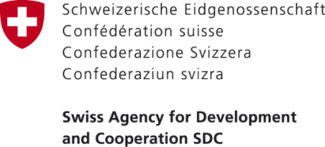
____________________________________________________________________
Press Release
24.08.2018
SIAP on "Improvement of pre-school education services"
In the villages of Mukur and Baigashka-Terek in the Avletim ayil aimak of the Aksy district, the opening of kindergarten №24 "Edelveis" for 50 places and kindergarten № 25 "Raatkan Kozhoakmatova" for 60 places were held.
On August 14, 2018 in the framework of the “Public Service Improvement” Project opening ceremonies of two kindergartens were conducted in the villages Mukur and Baigashka-Terek of Avletim AA.
The ceremony was attended by the representatives of the HELVETAS Association and Development Policy Institute, representatives of PSI project, the head of the Aksy rayon state administration, the head of the Aksy rayon’s education department, the head of the Avletim AO, representatives of the neighboring rural areas as well as teachers and children attending kindergartens, their parents and residents of Mukur and Baigashka-Terek villages.
During the project, the action plan was developed to improve the pre-school education services in Avletim AA on the basis of which the old school building in the village of Baigashka-Terek was renovated, the work was done on the modernization and reconstruction of the heating system, and the building was fully equipped and furnished. For the new building of the kindergarten in the village of Mukur, all the necessary furniture and equipment was also purchased.
- The total budget of SIAP: 2 483 253 KGS;
- Grant amount: 3 083 253 KGS;
- Municipality’s own contribution: 400 000 KGS.

With the support of the project "Improving services at the local level" as a result of improved services in the field of pre-school education in the villages of Mukur and Baigashka-Terek, today 110 children can attend preschool institutions. In addition, 22 workplaces for village residents were created and parent got the opportunity to work. As a result, the improved service creates favorable conditions for the social and economic development of the population.
“We are very happy that our children started attending the kindergarten. The provided service positively affects not only the development of our children but also provides us, young mothers, with the opportunity to work and self-develop. Now I'm seeking for a job, "- noted one of the mothers that took part in the ceremony.
In the Avletim AA, the provision of pre-school education services and its quality were the main problems that could not be solved for 30 years in this area. In the course of the project, along with the identification of problems at the local level, the number of training and seminars were also conducted to increase the capacity-building of local self-government bodies, deputies of local keneshes, and members of public organizations and service providers.

