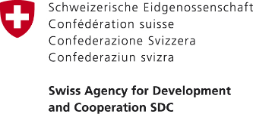

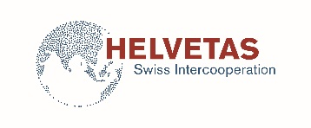

PRESS RELEASE

13 August, 2018
Bishkek, Kyrgyzstan

Switzerland helped to improve access to clean drinking water for more than 5,800 people in rural areas of Jalal-Abad province

On August 9, 2018, an official launch of improved drinking water supply service took place in Bagysh municipality of Jalal-Abad province of Kyrgyzstan.

A new 3245-meter water pipeline was installed, a 500 m³ reservoir was reconstructed at water intake facilities, a 180-meter-deep well was drilled, and a new deep-well pump with electronic control was installed. Water pipelines have been installed in 848 households and now more than 5,800 inhabitants of Oktyabrskoye and Kedey-Aryk villages of the Bagysh municipality have access to clean drinking water 24 hours a day.

This work was done thanks to the Public Service Improvement Project financed by the Government of Switzerland through the Swiss Agency for Development and Cooperation (SDC) and implemented by a consortium of organizations composed of Helvetas Swiss Intercooperation and the Development Policy Institute.

“Our residents are immensely happy that they finally have access to clean drinking water. People are willing to pay for water at the approved rate, as they understand that these funds will result in sustainable provision of water”, says Mr. Murzabekov, the head of the Bagysh municipality.

A new tariff for drinking water was agreed upon during public hearings and then approved by the local council. This tariff covers all current costs and also includes depreciation, which allows the Association of drinking water users, as the supplier of water, to be financially stable and efficient.

"I am glad to note that the water system has been rehabilitated. However, it is also of utmost importance that the management capacities of the local self-government have been improved and a new tariff has been established in consultation with the population. I hope it will ensure sustainable, affordable and quality service to all”, says Danielle Meuwly Monteleone, Deputy Head of Mission of the Embassy of Switzerland in the Kyrgyz Republic.

In total, the Swiss-funded Public Service Improvement Project supports the implementation of 36 Service Improvement Action Plans of rural municipalities for a total of 92 million soms, including contributions of 30% from the municipalities. The priority services supported by the project include sustainable access to safe drinking water, rehabilitation and accessibility of preschools and schools, improvement of communal and housing services in municipalities, etc.

For more details please contact the Embassy of Switzerland in the Kyrgyz Republic:
Tursunai Chodurova, Communications Officer, tel.: (0312) 301036 (ext. 803777), email: tursunai.chodurova@eda.admin.ch or Elena Zakirova, National Program Officer, tel.: (0312) 301036, email: elena.zakirova@eda.admin.ch

***

The Government of Switzerland provides assistance for the development of the Kyrgyz Republic. The overall objective of its cooperation program is to promote peace and social cohesion as well as responsive and inclusive institutions and a sustainable development to improve the well-being of the population. For more information, please visit https://www.eda.admin.ch/bishkek.

