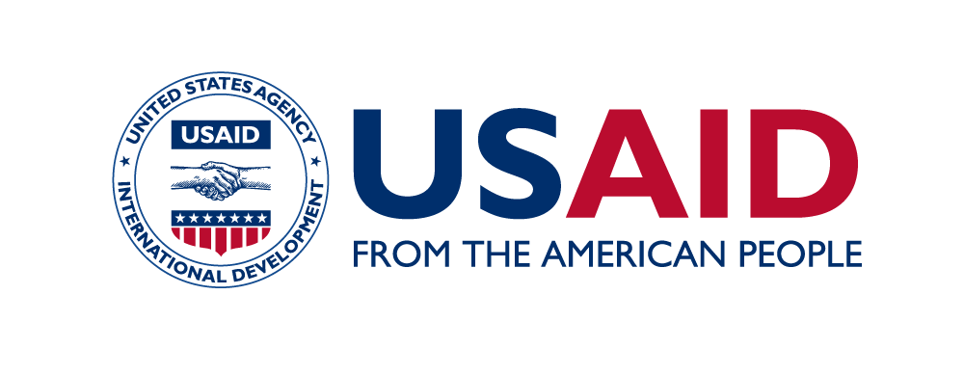

community and Municipal governance initiative
  - USAID’s Community and Municipal Governance Initiative is a five-year project that works with local self-governments to improve their performance, deliver quality services, increase citizens’ trust and promote peer-learning networks across the Kyrgyz Republic.
USAID helps to improve priority services such as solid waste management in rural areas
USAID CAMI Project

major focus areas
The project works with partner municipalities to demonstrate that by making systemic changes and improving their management practices they can achieve the necessary results using their own resources. After a thorough evaluation of how partner municipalities deliver and manage services, develop local economy, manage finance and operations, and interact with their citizens to identify main performance gaps, the project focuses on the following aspects:
- Effective service delivery. The project assists pilot municipalities in improving delivery of key services such as solid waste management, water supply, lighting or road reconstruction by helping to plan, budget, manage, and oversee in accordance with state regulations and international best practice.
- Improved citizens’ perception. The project seeks to reduce the gap in how communities perceive the work of their municipality and how local governments perform by engaging all citizen groups including women, youth and minorities to monitor the service delivery. Citizens are able to provide feedback on services while developing more realistic expectations of what local self-governments can deliver. The project promotes dialogue between municipalities and citizens through effective communications practices, public hearings, updating citizen charters and introducing innovative mobile feedback mechanism.
- Strengthened sustainability. The project promotes peer learning, best practice sharing and inter-municipal cooperation to ensure sustainability of effective service delivery and citizen engagement. Currently working with 32 partner municipalities the project aims to reach 50 rural and urban municipalities in the Kyrgyz Republic.
Duration: Oct 2016 – Sept 2021

Budget: $9.5 million

Implementing Partner: DAI Global LLC

Key Partners: Government of the Kyrgyz Republic, State Agency for Local Self-Government and Inter-Ethnic Relations (SALSGIR), local self-governments, the Union of Local Self-Governments, Development Policy Institute

Activity Locations: Jalalabad, Issyk-Kul, Naryn, and Osh regions

USAID Contact:
Timurlan Baiserkeev
tbaiserkeev@usaid.gov
+996 (0) 312 597240
Bishkek, Kyrgyz Republic
www.usaid.gov/kyrgyz-republic

Implementing Partner Contacts:
Robert Bodo
Robert_Bodo@dai.com
125/1 Toktogul Street, 10thfloor
Bishkek, Kyrgyz Republic
www.dai.com

expected results and achievements
- 453 local self-government (LSG) bodies across the Kyrgyz Republic received 1,000 copies of Collection of Legal Acts on Local Self-Governance (Sbornik) produced by the project in cooperation with State Agency for Local Self-Government and Inter-Ethnic Relations;
- Contributed to preparing the LSG Development State Program for 2018-2022;
- 229 people from 35 municipalities participated in 2 project’s regional forums to discuss best practices in service delivery and municipal management;
- 16 partner municipalities organized service provision; 6 of them launched priority services such as veterinary services, sports and extracurricular activities for youth, and solid waste management;
- Contributed to improved dialogue between key national, local and international stakeholders via roundtables, Coordination Council meetings, and public dialogues;
- Supported 16 municipalities in organizing budget hearings based on participatory mechanisms and focused on the needs of the citizens, such as education, health care, culture and utility services;
- With project’s support Teploklyuchenka municipality of Issyk-Kul region piloted mobile feedback mechanism via popular messaging application WhatsApp to interact with residents and conduct surveys about the quality of services;
- 32 municipalities strengthened peer learning via project study tours and roundtables;
- 1,126 LSG staff and experts trained on effective service delivery, institutional management, and improving LSG-citizen interaction;
- 3,298 people participated in 62 public hearings on service delivery, budget execution and citizen charters.

