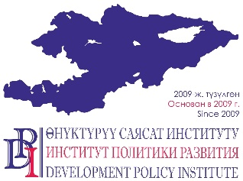
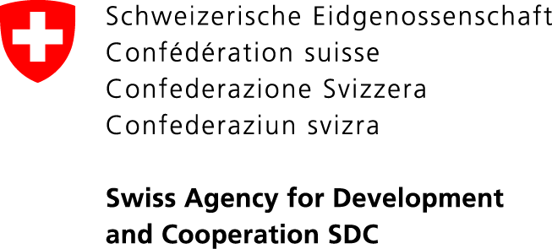

“Strengthening Voice and Accountability” Project
114, Shevchenko Street, Bishkek, 720001. Tel. (0312) 97-65-30 (31, 32). Fax: 97-65-29. Website: www.vap.kg

XX November 2020
Bishkek, Kyrgyzstan Press Release

SCHOOL OF FUTURE LOCAL COUNCIL DEPUTY FOR WOMEN

The "Strengthening Voice and Accountability" project announces an application call for the School of Future Deputies for women to encourage them and prepare for participation in the elections to local councils to be held in the spring of 2021.
The goal of the school is to create more favorable conditions for realizing the potential of active women in local councils of rural municipalities.
This project is funded by the Swiss Government and carried out by the Development Policy Institute in cooperation with the Union of Local Self-Governments of the Kyrgyz Republic.
Today the representation of women in rural local councils is only 13% of the total number of deputies. With the introduction of 30% quota, the participation of women in the upcoming elections is important to ensure that local councils are more inclusive and representative.
Up to 50 women aged 18 and above will be selected in January 2021. Participants will be capacitated on how to prepare and run for elections as well as on how to become a successful and accountable deputy, who is aware of her functions, role and available instruments. The School will include a series of online and offline trainings and mentorship.
The deadline for applications is December 11, 2020. A guide for applicants and an application form are available on the following websites:
- http://vap.kg/ru/about_project/vacancies/full/134.html
- http://dpi.kg/ru/press-room/news/full/1612.html
- http://gamsumo.gov.kg
- https://soyuzmsu.kg

For details for the media, please, contact: Nurgul Jamankulova, PR Specialist of the Project: 0555/0500 313-385, 0770 771-711, njamankulova@dpi.kg

