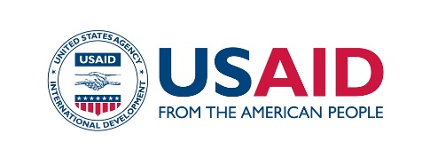
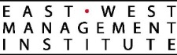

PRESS RELEASE

For immediate release: Contact information:
November 5, 2019 Kymbat Kadyralieva, Press Secretary,
Ministry of Labor and Social Development of the KR
Mobile: +996 (554) 011 049
E-mail: Kymbat3@mail.ru

Nurgul Jamankulova,
Information Policy Specialist,
Development Policy Institute (DPI)
Mobile tel.: +996 (555) 313-385; +996 (770) 771-711
E-mail: NJamankulova@dpi.kg

Government and Civil Society Organizations Implement State Social Procurement to Improve the Lives of Citizens in the Kyrgyz Republic

Bishkek. On November 5, 2019, the Ministry of Labor and Social Development of the Kyrgyz Republic (MLSD) held a conference on state social procurement. Over 100 representatives from government and non-government organizations attended it. It was confirmed during the conference that the state social procurement became an effective mechanism that allows the government to cooperate with civil society organizations so that the most vulnerable groups of the population have increased access to quality social services. The event was held in collaboration with the USAID Collaborative Governance Program and the Development Policy Institute.

In 2013, the MLSD was the only state body implementing state social procurement with a budget totaling 13, 9 million KGS. In 2019, there are three state bodies (MLSD, the State Agency for Youth, Sports, and Physical Culture, and the Ministry of Health) and five municipalities implementing SSP with a total budget of 43, 8 million KGS. The Ministry of Education developed its state social procurement program to increase children’s access to preschool education and plans to provide social vouchers to families in need.

Since 2017, the Development Policy Institute, with the support of the USAID Collaborative Governance Program, has been helping the MLSD, municipalities and civil society organizations to introduce social procurement mechanisms at the national and municipal levels. At the national level, the procedures for monitoring and evaluating the implementation of social procurement and the mechanisms of interaction between MLSD and civil society organizations, as executors of social procurement projects, were improved. The implementation practice of the Law on State Social Procurement, developed with the support of the USAID Collaborative Governance Program, was evaluated. Participating municipalities include the cities of Batken, Kochkor-Ata, Osh, Karakol, as well as the Uzun-Kyr, Lenin, and Kyzyl-Oktyabr aiyl aimaks. In 2019, the participating municipalities awarded ten state social procurement grants totaling 1,950,000 KGS for social projects. These focused on supporting migrants’ children, disabled children, homeless people, elderly people, victims of domestic violence, etc. It is important that local councils (keneshes) supported the introduction of an innovative approach, and approved the municipal social procurement programs.

“State social procurement is new for us,” noted the Vice Mayor of Karakol, Gulnaz Orozova, but “we have understood that social procurement is an opportunity to work with civil society organizations to resolve priority social problems of people in need, to develop a market of non-governmental providers of social services, and to apply innovative methods in addressing pressing issues of social development.”

The USAID Collaborative Governance Program (CGP) is a $9.5 million investment over five years to promote collaboration between civil society and the state bodies of the Kyrgyz Republic. The Program is funded by the United States Agency for International Development (USAID) and is implemented by the East-West Management Institute (EWMI).

