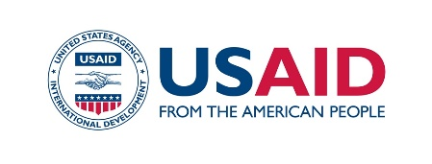
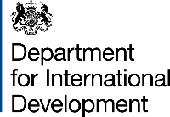
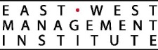

PRESS RELEASE

For immediate release: Contact information:
June 28, 2018 Nurgul Jamankulova,
Information Policy Specialist,
Development Policy Institute (DPI | ӨСИ)
Mobile: +996 (555) 313-385; +996 (770) 771-711
E-mail: NJamankulova@dpi.kg

Municipalities Partner with Civil Society Organizations to Implement Social Projects

Bishkek. On June 29, 2018, 11:00 a.m., at the Information Agency “Kabar”, a press session to be held for the media, where leaders of Batken, Karakol and Kochkor-Ata municipalities will announce the competition for civil society organizations to implement public benefit projects in accordance with the Law of the Kyrgyz Republic “On State Social Procurement (SSP)”.

The Mayor Offices of Batken, Karakol and Kochkor-Ata will become pioneers on introducing new forms of cooperation with civil society by engaging them in addressing priority social issues. The municipality of Batken seeks to partner with non-commercial organizations to offer creative solutions to solve waste utility issues and in Kochkor-Ata, the city will seek to address problems faced by teenagers from families who are in a difficult situation in Kochkor-Ata. In addition, the Karakol Mayor’s Office has defined the priority issues that focus on women without support, children with disabilities, and homeless citizens. Funds has been already allocated in the local budgets to address one of the mentioned issues through the SSP mechanism in partnership with a non-commercial organization.

“We seek to change the urban community’s attitude towards the waste disposal problem. This is a challenge requiring a creative approach. This is why we decided to request assistance from non-government organizations. Hopefully, such a partnership will be the first step in building a long-term collaboration between the mayor’s office, city council and the community represented by civil society organizations to promote the development of Batken and address its numerous issues” - said Mamyrjan Rahimov, the Mayor of Batken.

The head of the Kochkor-Ata mayor’s office staff, Chynygul Turdumatova, noted: “We came to the conclusion that it would be difficult to have teenagers’ behavior changed using conventional methods through family and school alone. They have different authorities, particularly those in mass culture or in the streets. This is why we decided to turn to civil society organizations so that they can offer non-conventional, innovative approaches to influencing teenagers in difficult situations and help them choose a path to success and prosperity. Delegating the projects to non-commercial organizations is a new experience for us. We feel anxious about whether the collaboration will prove a success, however, we hope for good results”.

In 2017, the new version the Law on State Social Procurement (SSP) was adopted and three municipalities pioneered to implement SSP at the municipal level. The Mayor’s Offices of Batken, Karakol and Kochkor-Ata have become partners of the project “Strengthening Capacity of the Ministry of Labor and Social Development to Implement State Social Procurement” implemented by the Development Policy Institute (DPI) with the support of the USAID Collaborative Governance Program (CGP). DPI has been providing consultative support to local governments throughout all stages of the project implementation including prioritization of issues, selection of non-profit organization and monitoring and evaluation of the project implementation.

The Collaborative Governance Program (CGP) promotes effective collaboration between civil society, the private sector, and the Government of the Kyrgyz Republic. The Program is funded by the United States Agency for International Development (USAID) and is implemented by the East-West Management Institute (EWMI).

