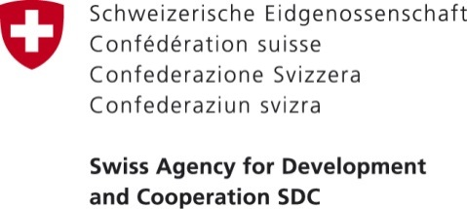

PRESS RELEASE

July 18, 2017
Bishkek, Kyrgyzstan

Switzerland supports service improvement at the local level
On July 18, 2017, an official ceremony was held to inaugurate a cultural center that will benefit over 3’500 residents of Ottuk and Kara-Shaar villages of Ulahol Aiyl Aymak. Leisure and recreation services provided by the cultural center have been improved with the financial support of the Swiss Agency for Development and Cooperation. The ceremony was attended by residents, representatives of the Ulahol municipality and local council, the Embassy of Switzerland to the Kyrgyz Republic, as well as the implementing organizations Helvetas Swiss Intercooperation and the Development Policy Institute.
Ulahol Ayil Aimak won a competition for the best Service Improvement Action Plan conducted in the framework of the Public Service Improvement (PSI) project funded by the Swiss Agency for Development and Cooperation and implemented by a consortium of organizations composed of Helvetas Swiss Intercooperation and the Development Policy Institute. The Service Improvement Action Plan is a systematic method that allows to identify priority public and municipal services as well as to plan and improve their organization and execution.
The cultural center will provide recreation services, such as dancing classes, language courses and other educational activities. It will have a playground for children and a WI-FI zone.
“From this day on, residents of the villages of Ottuk and Kara-Shaar will receive affordable services of good quality in the field of cultural leisure. All necessary conditions are created in the center to allow for people with disabilities take an active part in the cultural life of the village; before, there was nothing for them in the village at all,” - said Mamatkerimov Akylbek, Head of Ulahol AO. “ ”Previously, young girls and boys did not know what to do in the evenings, some would enjoy playing football, but the rest sat at home; from now on, they have a place where they can meet together, communicate and develop.”
In Ulahol Aiyl Aymak, the project also provides advisory and consultative support regarding the creation of a long-term plan for the provision of additional services in the field of leisure and culture taking into account the local priorities.
“It is crucial to keep in mind that improving service provision is an ongoing process. It is not only about procurement of new equipment or renovation of buildings. It is mostly about good management by local self-governments, ensuring that services are of good quality, can be accessed by all residents and are maintained in a sustainable way” – said René Holenstein, Ambassador of Switzerland to the Kyrgyz Republic.
In total, the PSI project supports the implementation of 35 Service Improvement Action Plans worth over 91 million soms with municipal contributions amounting to almost 28 million soms, corresponding to 30% of the total amount. Among the services to be improved there are nine initiatives to ensure sustainable access to safe drinking water, twelve initiatives to improve the quality and accessibility of preschool and school education, six plans to improve communal and housing services in municipalities etc.
***
For more details please contact: Tursunai Chodurova, Communications Officer of the Embassy of Switzerland in the Kyrgyz Republic, tel.: (0312) 301036 (ext. 803777), mobile: 0770 710054, email: tursunai.chodurova@eda.admin.ch or Elena Zakirova, National Program Officer of the Embassy of Switzerland in the Kyrgyz republic, tel.: (0312) 301036, mobile: 0550106235, email: elena.zakirova@eda.admin.ch
***
The Government of Switzerland provides assistance for the development of the Kyrgyz Republic and supports projects in areas such as health, private sector development, public sector reform, and infrastructure.

