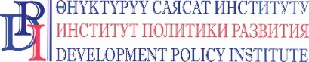
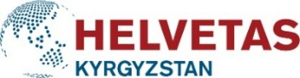
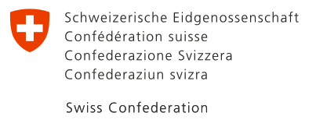

PRESS RELEASE

August 25, 2020
Bishkek, Kyrgyzstan

Switzerland protects waste and water service providers from bankruptcy

34 targeted rural municipalities of the Issyk-Kul and Jalal-Abad regions received a grant aid in the total amount of 5 809 400 KGS, which will be allocated to 26 selected local service providers affected by the COVID-19 pandemic in Kyrgyzstan.

The support was provided in the framework of the Public Service Improvement Project, which is financed by the Swiss Government and implemented by Helvetas Kyrgyzstan and the Development Policy Institute.

The grant aid covers the following three components:
- 4 100 000 KGS – financial support for 26 local service providers;
- 439400 KGS – support to purchase personal protective equipment for the municipalities and service providers
- 1 270 000 KGS – support to municipalities in conducting the information campaigns

The financial aid for the service providers is allocated as subsidies through the local budgets. These subsidies will partially compensate the lack of providers’ regular income in the II-III quarters of 2020 due to difficult economic situation caused by the COVID crisis. The financial support will be used to cover the urgent expenses incurred by the local service providers (waste collection, drinking water) in the mentioned period.

To prevent the further spread of the virus and to protect the employees and local service providers in the municipalities, the project purchased 260 sets of PPE, including reusable protective suits, glasses, face shields and three layer medical masks.

The project also allocates funds for informtional campaigns. It raises awareness on the importance of preventive hygiene measures and the important role of the local service providers in the prevention of the epidemic spreadingIt also appeals to citizens’ sense of social responsibility related to the due bill payments for the delivered services in order to keep the providers and services sustinable and continue to receive them.

The Swiss grant program helps the targeted municipalities in the two regions to support local service providers and prevent their bankruptcy along with service suspension at the local level.

For more details, contact: Erkin Abakirov, tel.: (0772) 530980, email: erkin.abakirov@helvetas.org
For more details about Swiss Development Cooperation in Kyrgyzstan, please contact: Tursunai Chodurova,
tel.: (0770) 710054, email: tursunai.chodurova@eda.admin.ch

***

The Government of Switzerland provides assistance for the development of the Kyrgyz Republic to improve the well-being of the population. Over the last 25 years Switzerland has granted more than CHF 430 million to Kyrgyzstan in the form of technical, financial and humanitarian support. For more information, please visit https://www.eda.admin.ch/bishkek.

HELVETAS Swiss Intercooperation is a Swiss non-governmental development organization with a mission to help disadvantaged people and communities in developing countries by actively improving their living conditions.

Development Policy Institute is a Kyrgyz noncommercial, nongovernmental organization. The mission of the DPI is to assist local communities and governments in the implementation of human rights and opportunities to live in dignity.

