Press Release
Public Service Improvement Project Phase II Launching seminar

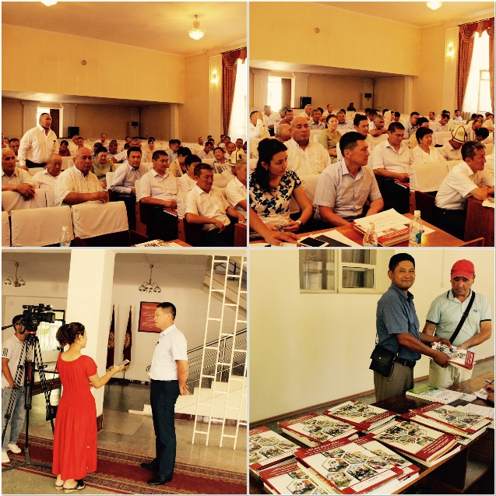
On 11th of July, 2019, in Jalal-Abad city, in the framework of the Public Service Improvement Project financed by the Government of Switzerland through the Swiss Agency for Development and Cooperation (SDC) and implemented by a consortium of organizations composed of Helvetas and the Development Policy Institute, the Project’s Phase II Launching seminar was conducted at the state administration of Jalal-Abad oblast.
The seminar was attended by heads and deputy heads of aiyl okmotus, deputy of Plenipotentiary representative of the government in Jalal-Abad region, heads of all 8 district state administrations of Jalal-Abad oblast (Aksy, Ala-Buka, Bazar-Korgon, Nooken, Suzak, Toktogul, Toguz-Toro and Chatkal), representative of the State Agency for Local Self-Government and Inter-Ethnic Relations in Jalal-Abad oblast, as well as by project representatives that in general were 89 people.
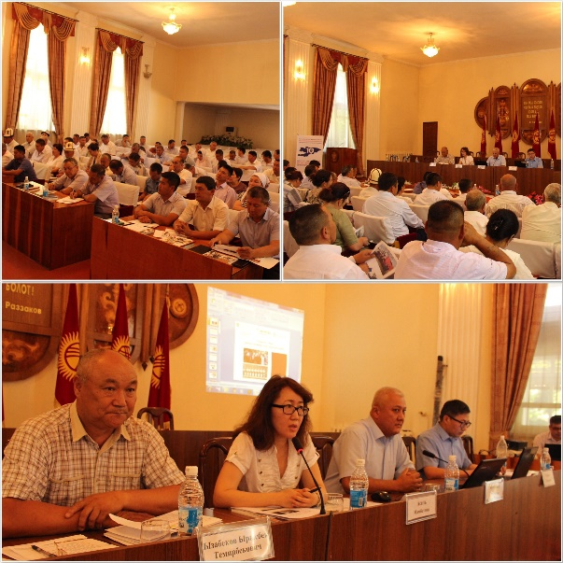
During the seminar presentations on the main results of the Public Service Improvement Project’s first phase, the purposes and objectives of the second phase of the project, as well as on the main thrusts of the project`s activities on the regional level and conditions/opportunities of municipality`s participation were presented to the participants. The heads of Kenesh and Beshik-Zhon municipalities also took the floor and shared their experience on service organization and provision, including their experience as pilot municipalities of the project during its first phase.
One of the crucial issues that evoked the most interest of the participants was inter-municipal cooperation in service provision to the population. They shared their views, concerns, have raised many questions, and were actively engaged in the discussion of participation possibilities and partnership conditions of the project’s phase II. Project representatives tried to answer all questions and provided detailed information regarding the planned project activities for upcoming four years.
The Project plans to conduct one more launching seminar next week in Issyk-Kul oblast, in the city of Karakol. The seminar plans to bring together the heads of all municipalities of the region, representatives of the state administrations of Issyk-Kul oblast, Plenipotentiary representative of the government in Issyk-Kul oblast, representative of the State Agency for Local self - Governances and inter-ethnic issues as well as the project representatives.

