Seminar on “Development of service delivery model in the Kyrgyz Republic”
held in Bishkek

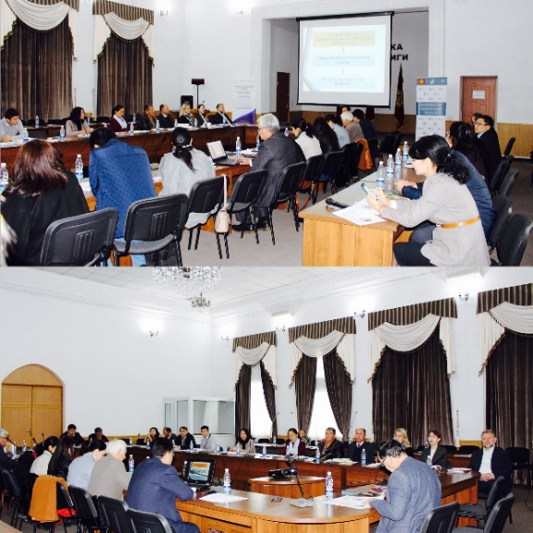
Ministry of economy of the Kyrgyz Republic jointly with the Public Service Improvement Project financed by the Government of Switzerland through the Swiss Agency for Development and Cooperation (SDC) and implemented by a consortium of organizations composed of Helvetas Swiss Intercooperation and the Development Policy Institute, conducted a seminar on “Development of service delivery model in the Kyrgyz Republic” on October 17, 2018.
The event was attended by the representatives of government agencies, the expert community, as well as the representatives of the international organizations.
This seminar was an introduction to the work on task 1 of the "Plan of measures for optimization of the system of services provided at the local level for 2018-2023" - to develop relevant “model” of services at the local level, which was developed by the Ministry of Economy of the Kyrgyz Republic with the support of the PSI project and approved on August 23, 2018 by a joint order of the Ministry of Economy of the Kyrgyz Republic (No. 98) and the State Agency for Local Government and Inter-Ethnic Relations under the Government of the Kyrgyz Republic (No. 01-18 / 104).

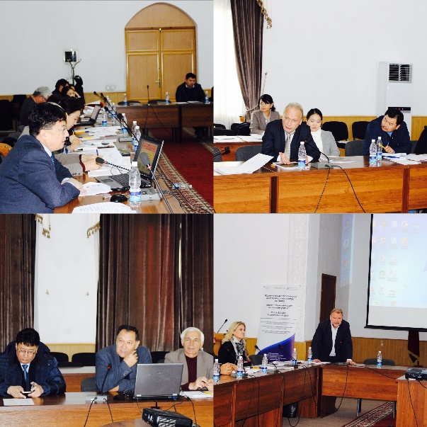
During the workshop, participants were actively engaged in discussions, covering a wide range of presented topics, such as:
- Review of the state service delivery system in the Kyrgyz Republic: achieved results and prospects;
- Approaches to the development of the service provision system in the Kyrgyz Republic from the standpoint of the theory of public services;
- Typology of “services” provided by government agencies and local government bodies in the Kyrgyz Republic;
- Best practices from abroad in service provision;
- The concept of service delivery model in the Kyrgyz Republic.
The proposed concept of a service provision model in the Kyrgyz Republic will be finalized based on the received proposals and comments and presented for further discussion at the end of this year.

