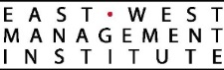
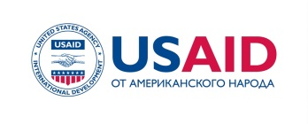
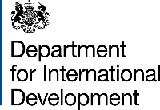

PRESS-RELEASE

For immediate release: Contact information:
September 17, 2018 Nurgul Jamankulova,
Information Policy Specialist,
Development Policy Institute (DPI | ӨСИ)
Mobile: +996 (555) 313-385; +996 (770) 771-711
E-mail: NJamankulova@dpi.kg

STATE SOCIAL PROCUREMENT IS A TOOL TO ADDRESS SOCIAL ISSUES IN COMMUNITIES

Bishkek. On September 18, 2018, at 10 a.m., at Park Hotel the Development Policy Institute, with the support of the USAID Collaborative Governance Program, will host a conference titled as “Experience and Prospects of Developing the Social Procurement”. Representatives of the ministries, local self-governments and civil society will discuss successes of implementing this new mechanism at the municipal level, as well as further prospects.

During the event, representatives of Batken and Kochkor-Ata will share their unique experience of using state social procurement to address priority issues of their communities with participation of civil society organizations. Participants will also discuss ways to replicate this experience in other municipalities and scale it up to national level.

The new Law on State Social Procurement and related legal acts were adopted in 2017. It enabled government institutions in the Kyrgyz Republic to procure services from civil society organizations to address various issues in the community. Development Policy Institute and USAID Collaborative Governance Program has been working with the Ministry of Labor and Social Development to implement the new law.

The Collaborative Governance Program (CGP) promotes effective collaboration between civil society, the private sector, and the Government of the Kyrgyz Republic. The Program is funded by the United States Agency for International Development (USAID) and is implemented by the East-West Management Institute (EWMI).

