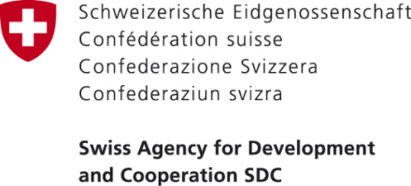
___________________________________________________________________
PRESS RELEASE
28.07.2018

SIAP ON “IMPROVING SERVICES IN THE SPHERE OF SPORTS”
A mini-football field was completed in the village of Airy-Tam of the
1-May ayil aimak of the Ala-Buka district
On August 15, 2018 in the framework of the “Public Service Improvement” Project financed by the Government of Switzerland through the Swiss Agency for Development and Cooperation (SDC) and implemented by a consortium of the organizations composed of Helvetas Swiss Intercooperation and the Development Policy Institute, an opening ceremony of the mini-football field was conducted in Airy-Tam village of the 1-May AA.
The ceremony was attended by the representatives of the HELVETAS Association and Development Policy Institute, representatives of PSI project, the head of the Ala-Buka district state administration, the head of the Ala-Buka district’s education department, the head of the 1-May AO as well as the representatives and residents of the neighboring rural areas.
During the project, the action plan was developed to improve services in the sphere of physical culture and sports in the village of Ayr-Tam, on the basis of which a mini football field was built.
- The total budget of SIAP: 3 476 196 KGS;
- Grant amount: 2 400 000 KGS;
- Municipality’s own contribution: 1 076 196 KGS.
With the support of the project "Improving services at the local level", as a result of the improvement of services in the field of physical culture and sports, suitable conditions were created for 350 young people living in villages of aiyl aimak. In addition to the process of improving services one more coach was attracted to the junior sports school. Previously, the budget deficit of the local government of in 1-May Aiyl Okmotu impeded allocations of funds for the provision of services in the field of sports on construction of new sports facilities and purchase of new sports equipment that, in turn, led to the discontent among the youth. Young people also experienced the negative externalities of the lack of a clear management system in the sphere of physical culture and sports and the organization of paid sports services. As a result of the lack of conditions for the proper use of leisure for young people, the number of crimes in this age group has increased.
“Improving services in the field of sports and culture is an outstanding achievement for us. By creating conditions for youth to do sports, we contribute to strengthening the health of young people, as well as reducing the level of crime among young people. I want to note that the local government was not limited to the construction of one mini-football field. As additional components, services for the population are also provided by gyms, as well as one sports hall”- said the Head of 1-May AO Muhtar Sherbaev.
In the course of the project, along with the identification of problems at the local level, the number of training and seminars were also conducted to increase the capacity-building of local self-government bodies, deputies of local keneshes, and members of public organizations and service providers.

